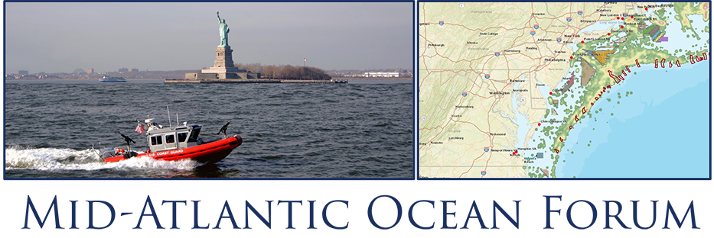

MID-ATLANTIC OCEAN FORUM WEBINAR
Tuesday, May 19, 2020
10:00 am - 12:00 pm

DRAFT AGENDA
Objectives:
- Generate a greater awareness of future regional ocean policy issues and activities; and
- Review MACO collaboration efforts in addressing regional issues and seek stakeholder input on further collaboration needs and opportunities.

9:45 a.m. Meeting Sign On Available

10:00 a.m. Welcome: Kisha Santiago-Martinez, New York State Deputy Secretary of State, Chair, Mid-Atlantic Regional Council on the Ocean Management Board

Overview and Logistics: Tony MacDonald, Facilitator

Keynote Remarks: Alicia Barton, President and CEO of the New York State Energy
and Research Development Authority

10:15 a.m. Policy, Climate and Technology Perspectives on Future Ocean Planning
- IOPC/ OSTP Perspectives, Deerin Babb-Brott, Principal, Assistant Director for Oceans and Environment, White House Office of Science and Technology Policy
- Changing Climate, Changing Ocean, Charlie Stock, Research Oceanographer, NOAA Geophysical Fluid Dynamics Laboratory
- The Future of Offshore Wind Energy Technology, Walt Musial, Offshore Wind Research Platform Lead, DOE National Renewable Energy Lab

10:45 a.m. Participant Perspectives, Q & A

11:00 a.m. Stakeholder Input: Future Directions for Mid-Atlantic Ocean Planning
MACO Steering Committee Discussion Leaders (TBD) -- Interactive Sessions

11:00 a.m. Building on Current MACO and Work Group Efforts

11:30 a.m. Brainstorming Other Collaboration Needs and Opportunities

12:00 p.m. Wrap up and Next Steps: Tony MacDonald, Facilitator

12:15 p.m. Adjourn

